Sarewitz 2004

How science makes environmental controversies worse

**Counting integers is hard if people want it to be**

Example is made of the counting of the 2000 Florida elections. Reflection:

* A very simple technical system (counting votes) still can show surprisingly complex behaviour
* Solution was eventually not found in technique, but in political and legal procedures. A simple technical problem can “outgrow” its confinements

**Excess of objectivity**

The idea is that scientific methods can deliver us with information that policy can be based on. However, because science on complex topics like climate change is inherently uncertain, “multiple truths” can be extracted from looking at the problem in different ways.

The discussion then grows larger around the facts and also the determination of those facts. Is science trustworthy? The important part is that the focus is shifted away from “what should we do” to “what is happening”

* A new perspective on a problem can always be found
* New scientists, other disciplines etc all have a different view
* “Flood the grounds with shit” is pretty applicable here

🡺 There is so much diverse literature around, that there is an Excess of objectivity from which politicians can or could decide to create entire narratives from. Each based on truth.

* The underlying issue here is the targeted selection of literature to support a pre-existing position
* More science is not the answer here. Rather it stokes the flames of uncertainty even more

**Value in discipline**

* Could scientific orientation be related to the values that one holds?
* Science divides up the environment partly by disciplinary orientations that are characterized by particular methods, hypotheses, standards of proof, subjects of interest, etc.
* While some see a grand unification of all knowledge as an inevitable product of scientific advance, thus far the growth of disciplinary scientific methods and bodies of knowledge results in an increasing disunity that translates into a multitude of different yet equally legitimate scientific lenses for understanding and interpreting nature

All scientific disciplines work from slightly different viewpoints. Show a cow to a biologist, an aerodynamics expert and an economist and they will all have a valid, but different perspective. Human factors such as subject-specific best practises and review methods for designated papers all create different kinds of science. The method is in essence the same, but the humans practising it increasingly differ in views. These views, in some heated cases, compete with each other to be “the right one”.

🡺Immense diversity in human values and interests, coupled by the hilariously complicated systems they study, create a problem of competing perspectives that are not coherent. The inability to find a coherent theory about a natural phenomenon is called “Uncertainty”.

**Origins of uncertainty**

Leading axiom behind uncertainty research:

*If we can reduce uncertainty around a phenomenon, the course of action surrounding that phenomenon will become more clear.*

Uncertainty is often measured in estimates

* A 95% confidence interval is a powerful tool for scientists.
* However do not underestimate its power of politicians. They will often assume a 95% surety of occurrence as it being concrete future-reading.
* If something doesn’t occur, then the question shifts whether the estimate was right, but in the tail (<5%), or that scientific analysis was incomplete.

🡺 Uncertainty estimates should not be read as “the chance that X will happen in nature”. A confidence interval is a combination of the understanding of the system X at that time, combined with the analysis done that something will occur based on those understandings.

Be careful who studies uncertainty

Some scientists may have an incentive to over or underestimate the confidence in data. For example, if the burden of research on the strength of hydro dams falls upon the same agency that should pay for repairs, there isn’t a large incentive to preach more uncertainty that necessary. Even sneakier, certain habits such as a default +-10% uncertainty test might result in the “standardisation” of uncertainty, if there is no incentive to research further.

Uncertainty reduction possible?

* Each scientist studies a topic at a slightly different angle.
* With climate change for example, there is a near infinite amount of angles to study uncertainty from.

🡺Each extra analysis includes more researchers with more results. More research then inevitably leads to not a smaller, but a larger band of uncertainty around KPI’s.

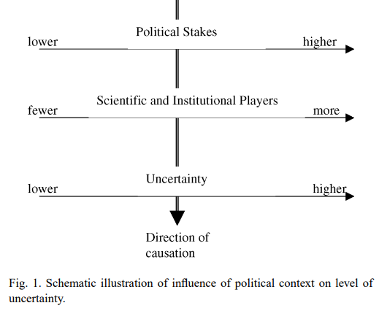

**Why scientize**

Why, then, do some controversies become more scientized than others? Possibilities include:

1. advocates or opponents of action believe that scientific knowledge will advance their value positions or interests;

2. advocates or opponents of action believe that scientific uncertainty will advance their value positions or interests;

3. scientists are involved in the political framing of the controversy; and

4. available policy options for addressing the controversy are insufficiently broad or appealing to attract a political consensus.

Reasons why some controversies do not become highly scientized might include:

1. value positions are well articulated from the beginning of the controversy;

2. values underlying the controversy are widely viewed as inappropriate for scientific adjudication;

3. effective mechanisms for eliciting and adjudicating value disputes are already in place and well-accepted; and

4. available policy options are broad and appealing enough to attract a political consensus.

Scientisation can be a tool for politicians to shroud controversy about inherently unknowable or undesirable facts.